
SCSE2123: Software Requirements Engineering
Semester 01, 2025/2026

Requirements Model Document

<Project Title>

<Version ID>

<Printing Date>

Prepared by: < Team name>
<Team Motto>

DOCUMENT CONTROL
General Information
Document Name | : | <Document ID> – Requirements Model Document
Audience | : | << Targeted audiences >>
Prepared by | : | <<Name of your team >>
Prepared Date | : | << Date >>
Revision Date | : | << Date >>
Printed Date | : | << Date >>
Reference Number | : | << Reference number >>
Version | : | << Version >>
Document Level | : | Confidential | Open

- Current Version Document
 | Name | Designation | Signature | Date
Prepared by: | <<Member name>> | <<Role>> | <<Compulsory>>
Verified by: | Dr. Noraini Ibrahim | Head of Project | TBD | TBD

Item | Page No | Prepared by | Moderated by
- Introduction
- Functional Perspective: Use Case (UC) Documentation (Diagram – UML UCD)
- Functional Perspective: Use Case (UC) Documentation (Specification – UCS) & UML Activity Diagram (AD)  UC001 <Name> UCS & AD  UC002 <Name> UCS & AD…  …  ….  ….  ….. |  | //Assign each UCS & AD(s) to different team members
- Data Perspective: UML Domain Class Diagram (DCD)
- Behavioral Perspective: State- Transition Diagram (STD)
- Conclusion
- References
- Appendices

1. INTRODUCTION
<Provide brief introduction to this Phase 2 report ~ to present the model the analysis results of elicited user requirements (continuation from P1 report), i.e. Requirement models document– UML Use Case diagram, UC specifications, UML activity diagram, UML domain class diagram, UML state diagram🡪 include citations whenever possible from the listed references.>
<Scope of document – your client’s expectation from this document i.e., purpose of Phase 2 report>

2. FUNCTIONAL PERSPECTIVE: USE CASE DOCUMENTATION
  - Use Case Diagram (UCD)
<Introduce and briefly describe elements in the developed UCD – actors, use cases with ID stated in the oval notation + <verb><noun> naming rule, relations <include> <extend> if any – justify why it being applied>
<Diagram with caption e.g., Figure 1.0: Use Case Diagram for SystemName 🡪 Ensure no rules violation, clear diagram, apply landscape view setting if required to improve readability aspect>
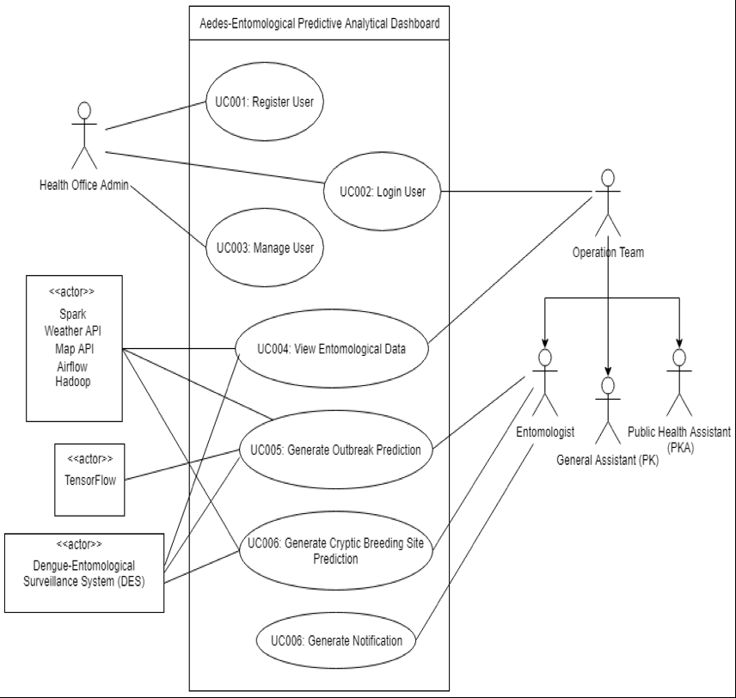
//Example ~ generalization actors concept applied
Figure 1: Use Case Diagram for Aedes-Entomological Predictive Analytical Dashboard System

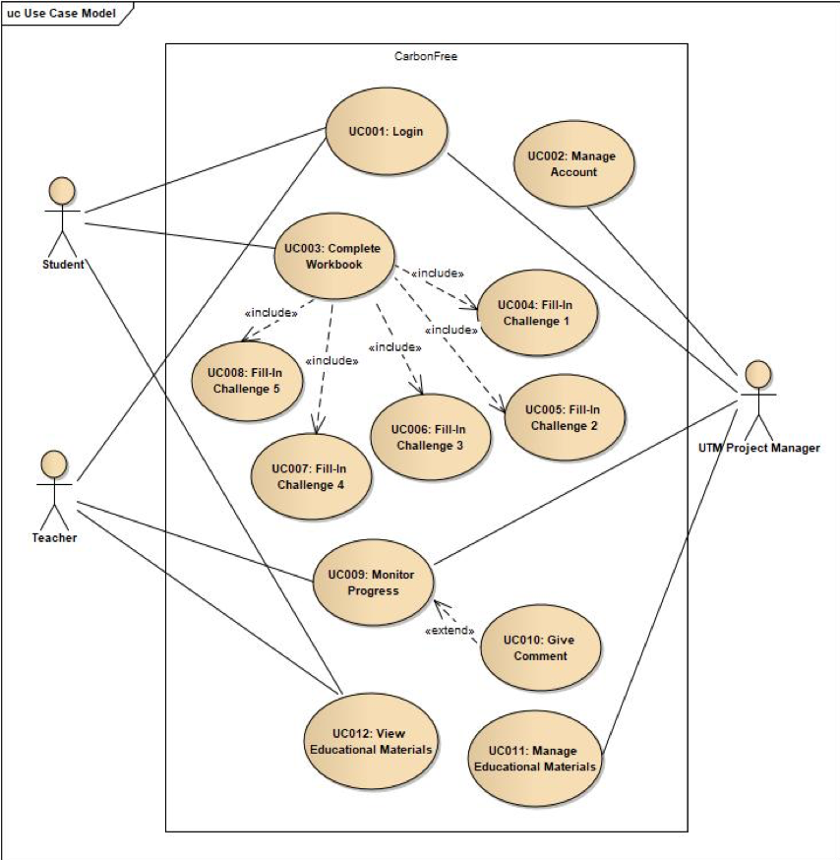
//Example ~ <include> & <extend> applied
Figure 1: Use Case Diagram for CarbonFree System

  - Use Case Specification (UCS) & UML Activity Diagram (AD)
< All identified use cases in the diagram were described and provide complete documentation elements i.e. the UC unique ID & name, descriptions, related Actors, pre-conditions, post-conditions, normal flow (NF), alternate flow (AF), exception flow (EF). Refer the recommended UCS Table 3.1 below>

Table 2.1 Use Case Specification for UC <ID> <Name>
Use Case ID | //Unique ID with UC<#>
Use Case Name | //Unique Name with <Action> <Verb> naming rule
Description | //Brief description about the this UC
Actor(s) | //List the primary i.e. direct/end-users, secondary i.e. external/interfacing systems (e.g. API) that shall trigger/involved in this use case – can use stickman symbol or alternative rectangle with <system> stereotype, can apply generalization for general vs specialized actors
Pre-condition(s) | //List/describe the constraint(s) that should be checked/met to initiate/execute this use case
Normal Flow(s)- NF | // Synonym: Main/Primary Scenario  # The <actor> <perform action>  # The <system> <response to actor action>  e.g.: 1. The user enter input id and password in the login form  2. The system validates the inputs….  3. …
Alternative Flow(s) - AF | // Synonym: Alternative Scenario ~ when checking condition (s)/ decision (s) occur i.e. true/false, Boolean  e.g.: AF1. Cancel Operation
Exception Flow(s) - EF | // Synonym: Error handling Scenario ~ seldom relates to system mechanism to manage flow control of expected errors  e.g.: EF1. System Failure to Update Database
Post-condition(s) | //List the system states after use case ends/executed

//Example Table 2.1 Use Case Specification for UC001 Register User
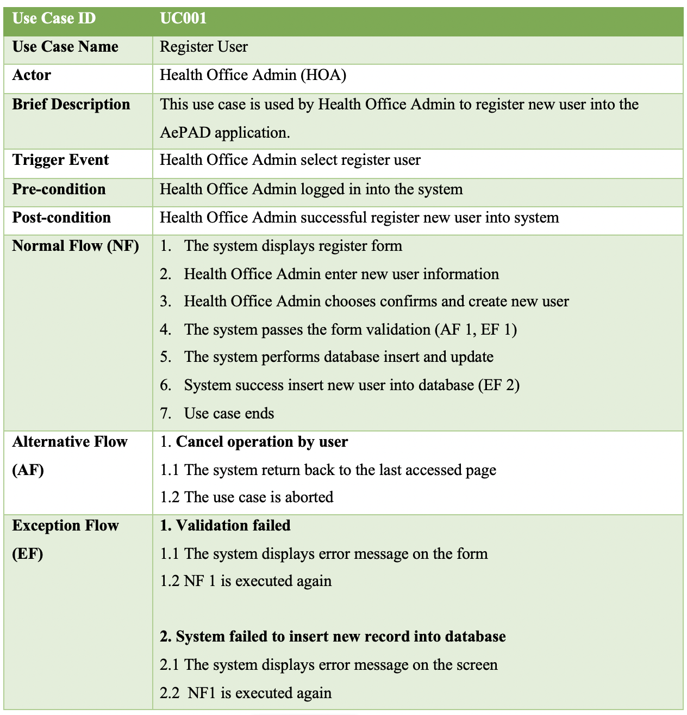

< Add UML Activity Diagram for the UC here - Correct shapes/ notation/ symbols were applied i.e., start-end, fork-join activities (concurrent / parallel events), branch-merge activities (alternative paths events). Used appropriate vertical view if multiple lanes are applied.>
< Diagram with caption e.g., Figure 2.1: Activity Diagram for UC <ID> <Name>. Developed for all identified use cases in the UCD. Complete activities or flow of events for related use cases based on scenarios in documentation (NF, AF & EF) were included. AD is briefly explained in paragraph>

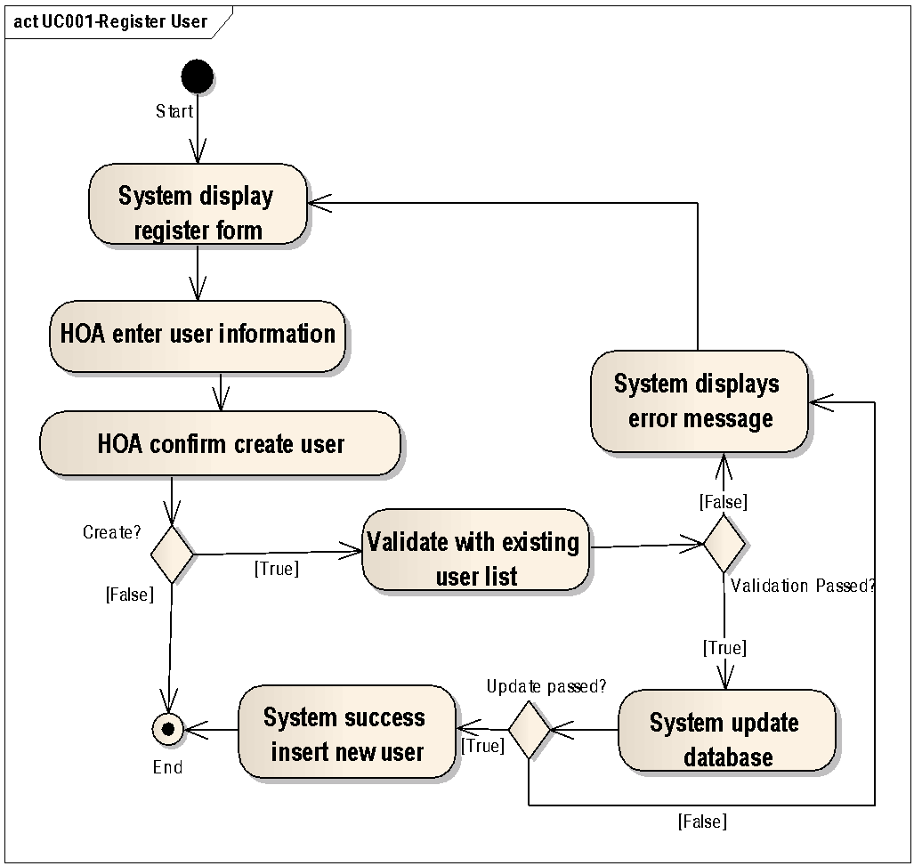
//Example Figure 2.1: Activity Diagram for UC001 Register User

//Example Table 2.1 Use Case Specification for UC003 Manage User
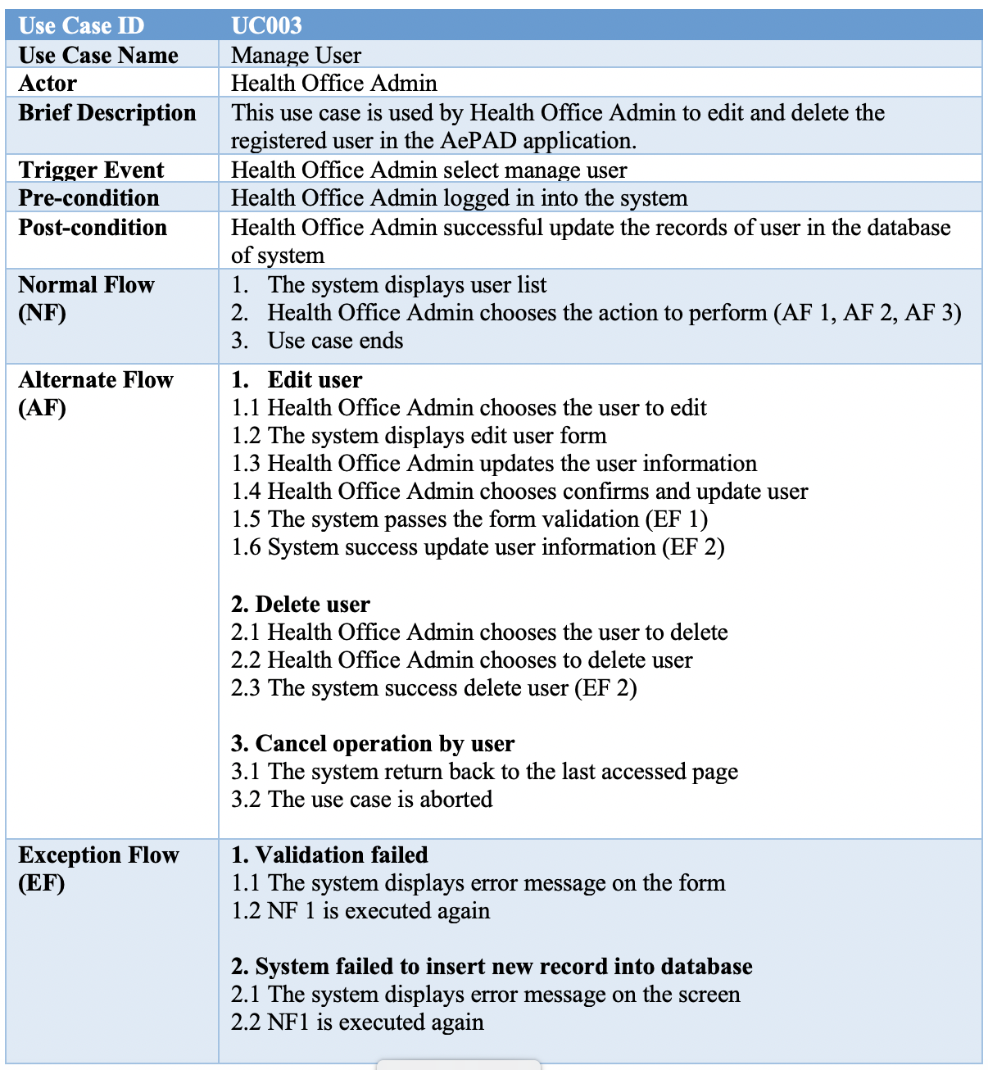

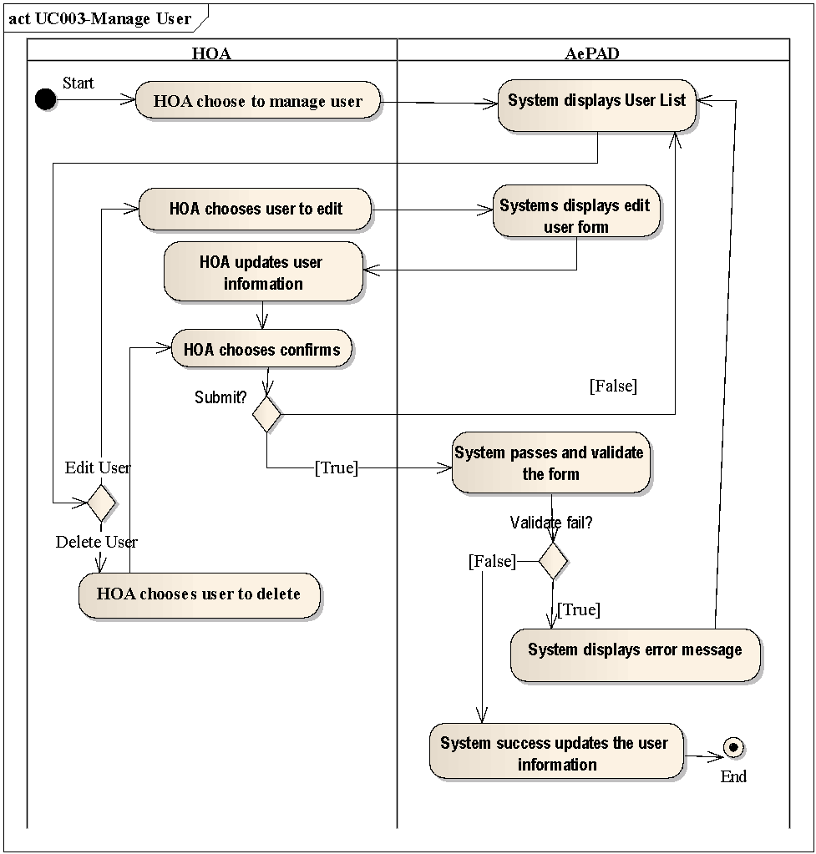
//Example~ partition/swimlane with vertical view
Figure 2.2: Activity Diagram for UC003 Manage User

//Repeat until all UCS & AD are added in this section.

3. DATA PERSPECTIVE: UML DOMAIN CLASS DIAGRAM (DCD)
<Introduce and briefly describe elements in UML domain class diagram – identified classes (good to have identified attributes), specified relationships i.e. association (with specified roles and multiplicities- align with Business Rules in P1 document URD), generalization, composition, or aggregation>

<Diagram with caption e.g., Figure 3: Domain Class Diagram for SystemName 🡪 All relevant objects/classes and its relationships/associations were identified. DCD is briefly explained in paragraphs>

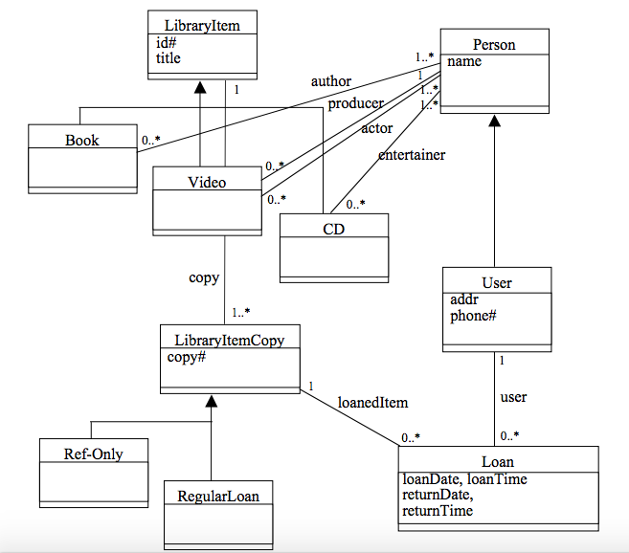
//Example Figure 3.0: Domain Class Diagram for Library System

4. BEHAVIORAL PERSPECTIVE: UML STATE-TRANSITION DIAGRAM (STD)
<Introduce and briefly describe elements in UML state-transition diagram – Correct shapes/ notation/ symbols were applied i.e., start/ends states, relevant states. Correct transition specification (event [condition] / action] were defined between states.>

<Diagram with caption e.g., Figure 4.0: State Transition Diagram for Class 🡪 All relevant states and its transitions were identified. STD is briefly explained in paragraph>
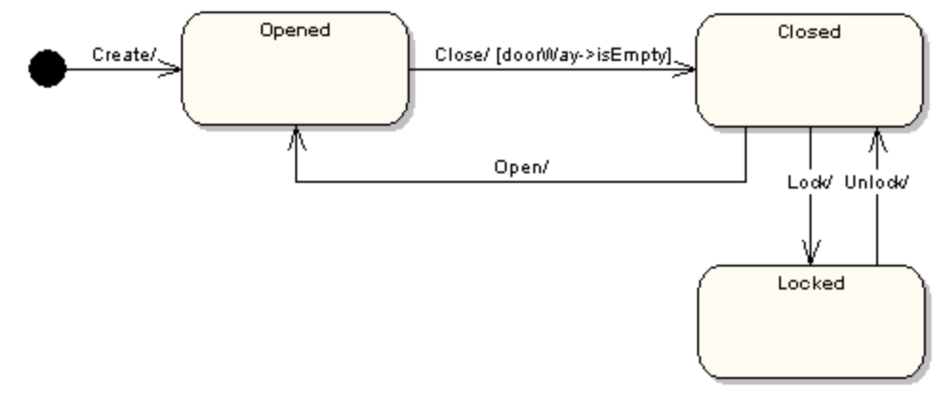
//Example Figure 4: State Transition Diagram for TrainDoor Class

5. CONCLUSION
< Describe briefly the conclusions consisting of the lesson learned and the reflections your team gained from this Phase 2 report document >

6. REFERENCES
< Bulleted number of lists all the references that being written based on APA style guidelines🡪 ensure all listed references are cited in-text any sections that are suitable throughout the overall P2 report document. Else, this section should become Bibliography>

7. APPENDICES
[Include any related documents, screenshots of legacy system, interview and survey questionnaires – that were observed and compiled to understand the system and it’s relevant context – boundary, scope, objects, interfaces]
- Appendix A: Originality/Similarity Report
  - Attach the originality/ similarity report (.pdf file) from Turnitin checking.
  - UTM teaching and learning best practice for plagiarism policy is similarity index must less than (=<) 20%
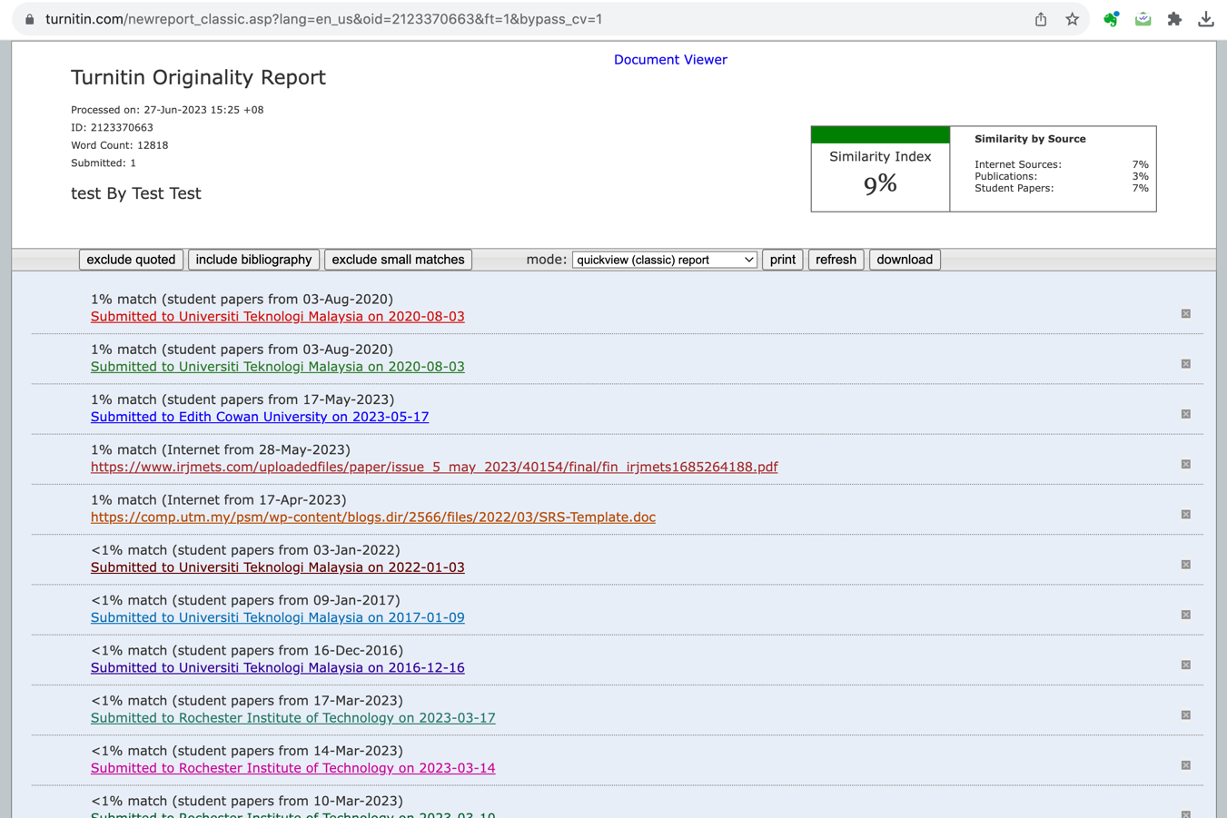



- Appendix B: List of Prompts Used
  - Include verifiable evidence of the use of Generative AI tools such as ChatGPT, QuillBot, etc., in the creation of your assignment.
  - This evidence may include screenshots and URL links
  - Failure to provide this evidence when actually you are using generative AI in your work will result in ethical violations and may lead to plagiarism penalties, ultimately resulting in a grade deduction to zero marks.

* Generative Artificial Intelligence refers to a type of artificial intelligence technology that can produce various types of content, including text, images, audio, and synthetic data
Example: Screenshot
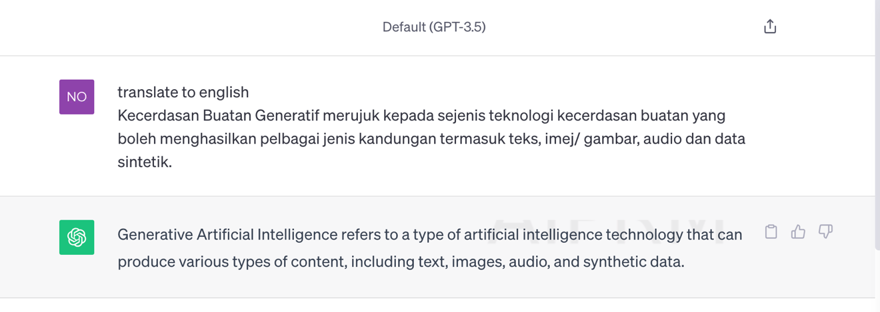
Figure: Screenshot Generative AI translation from BM to English
Example: URL
https://chat.openai.com/share/0ff33fdd-9b7f-407c-9b74-b744ec698a7e>

